Lesson Plan Template

Lesson Plan Information
Subject: Chemistry/biology |  | Curriculum alignment:
Topic: Reading and Understanding Food Labels |  | Duration: 45 minutes
Grade Level: | Age Range: 16-18 | Language: Native

Prior Knowledge and Skills Needed
(Prior knowledge is the knowledge the learner already has before they meet new information)
Knowledge regarding food additives, sugar and trans fats that can be found in the Chapter II, section 2 and 3 of the student manual, can be useful.

Objectives
(Learning outcomes are what students are expected to learn after completing the lesson plan)
Learning how to read and understanding food label and food packaging

- Students will learn to distinguish food labels and food packaging

- Students will develop their critical thinking skills with regards to misleading nutrition claims and misleading illustrations on food packaging

- Students will learn how to read and interpret the list of ingredients and nutrients on food labels

Thanks to the knowledge acquired during this lesson, students will be able to make informed food choices. According to the food label, they will be able to determine, which product is good for their health.

Instructional Strategies
(Teacher approach to helping students achieve the learning objectives and meet their needs)
- Practical representation of experiment
- Group discussion
- Brainstorming
- Teacher assessment

Learning Activities
(Opportunities provided for students to develop knowledge and skills of the learning objectives)
Exercises 1 and 2 do not guide students with already formulated questions that might help them to read the labels, as the purpose of these exercises is primarily to develop students’ critical thinking skills.

Exercise 1. Food packaging and food label (15-20 min)

→ The teacher asks if the students know the difference between food packaging and food labels. At the end of the discussion, the information that should come out is:

Food packaging first purpose is to preserve the product from contamination. It also provides information about the product such as its name and brand. Very often, there is an image representing the food product, which can be more or less truthful. It also includes nutritional information as well as visual content.

Food label is most often displayed on the back or the side of the packaging and includes a list of the product’s ingredients as well as a nutrition table. The latter provides information about the amount of carbohydrates (such as sugar), fat, proteins, etc. contained in the product and their corresponding nutritional values.

→ The teacher opens a discussion on which information should be found:

- on a product’s packaging?
- on a product’s label?

The teacher divides students into groups of 4 or 5. The teacher gives several food labels to each group. Each group of students will have to classify the food labels of several products of the same type (for instance several boxes of cookies), paying attention to the ingredients and all the information written on the labels, from the healthiest product to the least healthy one according to them. Students will therefore need to highlight all the ingredients that are potentially bad for the health.
Each group of students will have to present their findings in front of the class. If possible, the teacher will show the labels each group had to classify using a PowerPoint presentation to make sure every student can see the labels properly while their peers are doing their presentation.

→ The teacher summarises the students’ findings, and makes corrections whenever needed. The teacher then reminds that when choosing a product and reading a label, one needs to pay attention to the ingredients and in particular to the presence of sugar, additives, trans fats, allergens, as well as the length of the list of ingredients and what the first ingredient written on it is.

→ The teacher can decide to go a bit further on this exercise and hand out cards to his or her students. The teacher can refer to the sample cards that are available on the TAO online website for the teachers. On each card, specific personal characteristics will have to be written (for example, a card will mention that the person carrying this card cannot eat nuts, is vegan, diabetic, cannot eat gluten, or does not eat pork...). According to that, the students will have to analyse the products that are in the classroom and check which ones they might or might not be able to eat.

Exercise 2. Misleading food packaging (20 minutes)

The teacher shows the students 2-4 short ads for different food products (with strongly misleading claims such as “very natural”, “zero percent sugar” or plenty of healthy ingredients displayed that the product barely contains). The students take notes on observations they make while watching the advertisements. The ads can alternatively be printed if no audio-visual material is available.

Afterwards, the teacher asks for feedback from the students on the ads, whether they would buy the products, and why, and what impression the advertisement left on them.

The teacher then distributes the corresponding food packaging to the students, who will work in groups of around 4. The pupils are to observe the food packaging and highlight any differences they find to the claims made in the ad. The students will notice through reading the food labels that in comparison to the ad, the products often do not contain as many healthy ingredients as claimed and while some may indeed contain 0% sugar, this is often replaced by harmful additives or more fat.

A short group discussion will conclude this part. The teacher will highlight the importance of not blindly believing claims put forward in ads. The students can also discuss some of the following questions;

-Do you think the rules surrounding misleading advertisements are sufficiently strict?
-Would you prefer more or less regulation?
-Should the responsibility of healthy eating be put on the state/ the EU as regulating bodies, or rather on the consumers, who as adults should make their own choices?

Exercise 3. Logos and symbols (5-10 min)

After a short introduction on the purpose and the variety of food logos and symbols, the teacher asks students to pick the right answers in this short quiz (it can either be printed for each student individually or be shown on a Power Point presentation):

This logo means that:

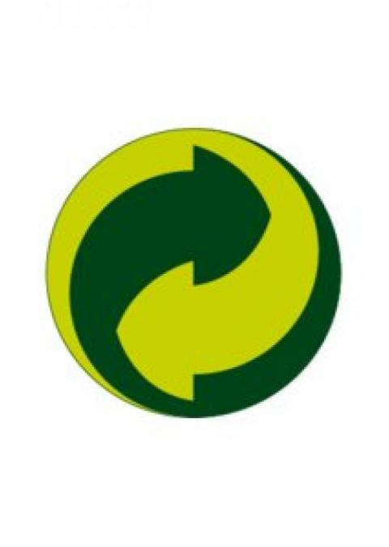
- This product is recyclable

- This product is produced by a company, which pays a financial contribution for the recycling system of packaging.

c) This product is local

d) This product is organic

The right answer is the second one.

Commonly recognised as the symbol indicating that a packaging itself is recyclable, this logo actually indicates that producer of this packaging has made a financial contribution towards packaging recycling.

When a product displays this logo and contains more than one ingredient, what is the total Fairtrade percentage ingredients that the product must have?
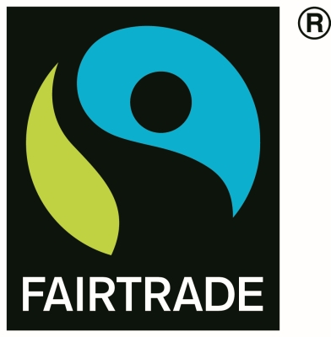
100%

75%

50%

20%

- The right answer is 20%.

The Fairtrade label ensures a fairer price for the producers and decent working conditions for the workers. For products containing more than one ingredient and provided that they exist in that form, the label guarantees that all ingredients are fair trade. The product will need to have at least 20% of fair trade ingredients. This criterion is the minimum that this label guarantees. Indeed, if the product contains only ingredients available in fair trade, it must use them, and therefore can no longer be satisfied with the 20% limit.

Which of the following claims is NOT true?

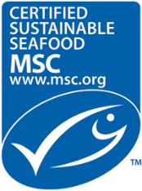
    - This logo ensures that the fish does not contain heavy metals.

    - This logo ensures a minimal environmental impact

    - This logo ensures effective fisheries management

    - This logo ensures the sustainability of the fish population

- The sentence to find is the first one.

The letters MSC on the logo stand for ‘Marine Stewardship Council’. Based on established standards, authorisations to carry this label are granted if the fishery is sustainable and well managed. The three core principles are: to have an effective fishery management, to minimise the environmental impact and to maintain a sustainable fish stock.
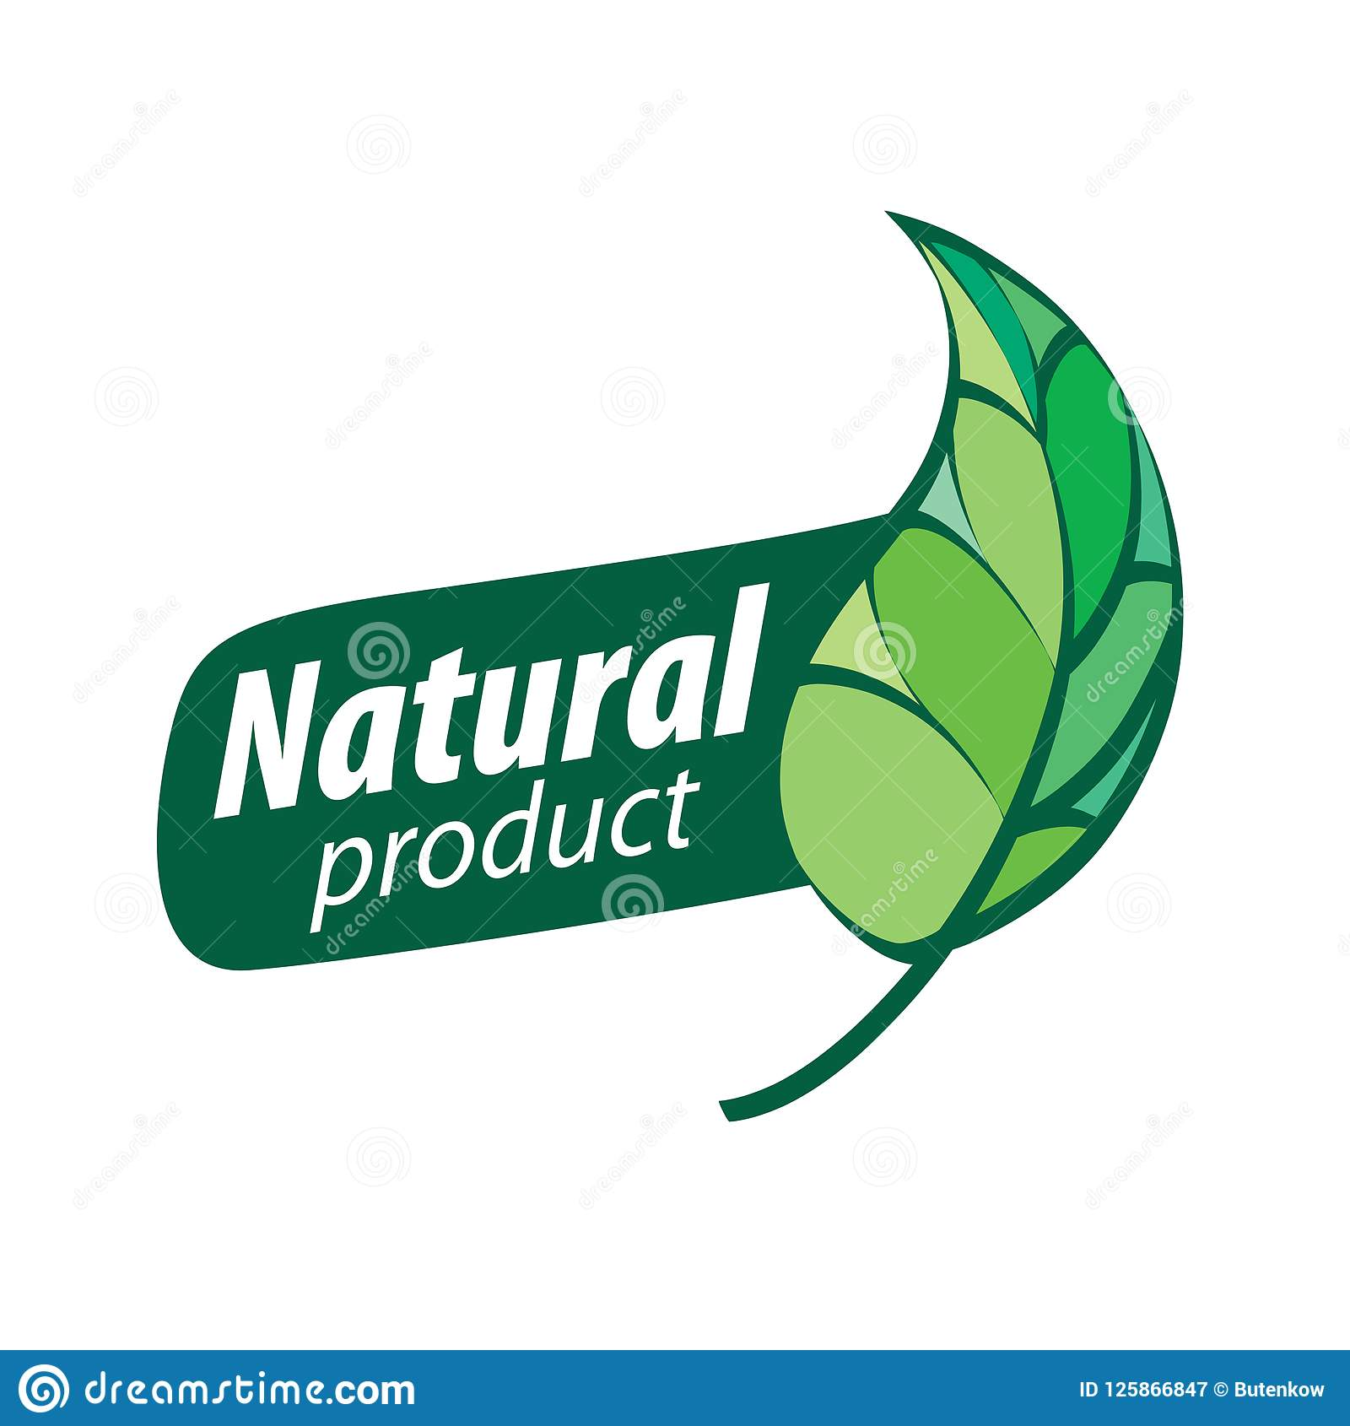

Is this an official logo? Yes No
The teacher can take the chance to explain the process by which labels are created and who approves and controls them.

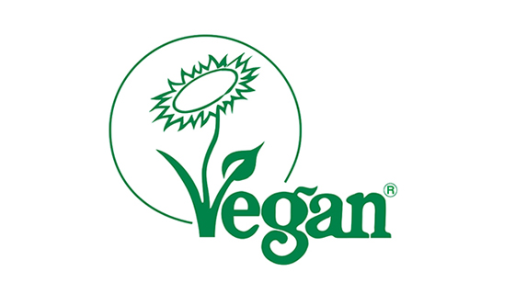
Is this an official logo? Yes No

Is this an official logo? Yes No

- Right answers: No, yes, yes.

The teacher finishes the lesson with a short summary on the importance of knowing how to read food labels and staying alert when choosing food products.

Assessment and Evaluation
(Assessment(s) before, during, and after the lesson)
Exercise 1: The student actively takes part in the group discussion and is proactive during the work in smaller groups.

Exercise 2: The student shows critical thinking when evaluating the shown advertisements and actively participates in the discussion.

Exercise 3: The student completes the quiz, is able to identify some of the official logos and understands that not all claims on food packaging can be trusted.

Resources
(Materials / Equipment)
- Printed and laminated pictures of labels
- Actual packaging of common products for the students
- A PowerPoint with pictures of the labels in a large size
- Images of logos and symbols

Extensions
- Students will have to take a picture of one or several packagings (at home or in a shop) that they found the most misleading
- If the school has an online platform, students can post online their pictures, which will be discussed during the next session, creating a gallery of the most misleading products.

The students can keep the cards they received during the second part of the exercise 1 and go grocery shopping taking into account what their cards were saying. They will have to ask themselves which products they could eat and if the ingredients they cannot ingest were easy to find on the labels.

