MEMORANDUM OF UNDERSTANDING
Between __________________________________________
and the project coordinator, SAFE – Safe Food Advocacy Europe
Floriana Cimmarusti, Secretary General
Rue de la Science 14, 1000 Bruxelles, BELGIUM

B.C.E.: 0578.909.064

- General information
Name of the school:
Address:

Legal representative:
Person of contact:
Teachers involved in the training:

Starting date:

- Purpose
The objective of this Memorandum of Understanding is to set forth understandings and intentions of the partners to enable the signatory organisation to implement the nutrition training and to use the pedagogical material developed during the Erasmus+ project "Tackling Adolescent Obesity". The partners acknowledge that this Memorandum of understanding does not create an obligation to commitment of funds, nor does it constitute a legally binding commitment by an of the partners.
- Goals and Objectives
The Erasmus+ project “Tackling Adolescent Obesity” aims to create a more inclusive school environment towards adolescents living with overweight or obesity and to provide teachers with tools and guidelines to help their students taking heed of their body and mind. The school XXX shares a common interest with the consortium in raising awareness of problems related to obesity and overweight among adolescents and wishes to implement the training in its establishment.
- Activities
In order to implement the training within its institution for the students, the school is able to
- Distribute to teachers and students in biology/physical education/civic education classes, the Student Handbook and the Teachers’ Manual
- Develop lesson plans inspired from the education materials
- Create information sessions to raise awareness on problems related to obesity and overweight
- Request access to the teachers' room on the project's digital platform
- Share new learning content and methodologies in the teachers’ room
- Disseminate the training to other schools
- Translate the content of the education materials in their own language
- Share the project’s social media pages
- Share the experience of the training on their own social media pages
Finally, teachers and students must complete an evaluation with their comments to assess the quality of the training at the end of the course.

Signature:  Name of the legal representative:  Date: | Signature:  Floriana Cimmarusti, SAFE’s Secretary General  Date:

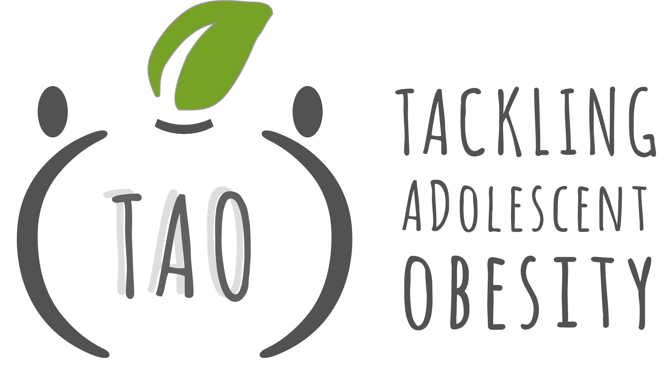
Have some questions or need further information? Do not hesitate to contact us.
SAFE FOOD ADVOCACY EUROPE
Rue de la Science 14
BRUSSELS, BELGIUM
Phone: 0032.2.880.36.46
euaffairs@safefoodadvocacy.eu

